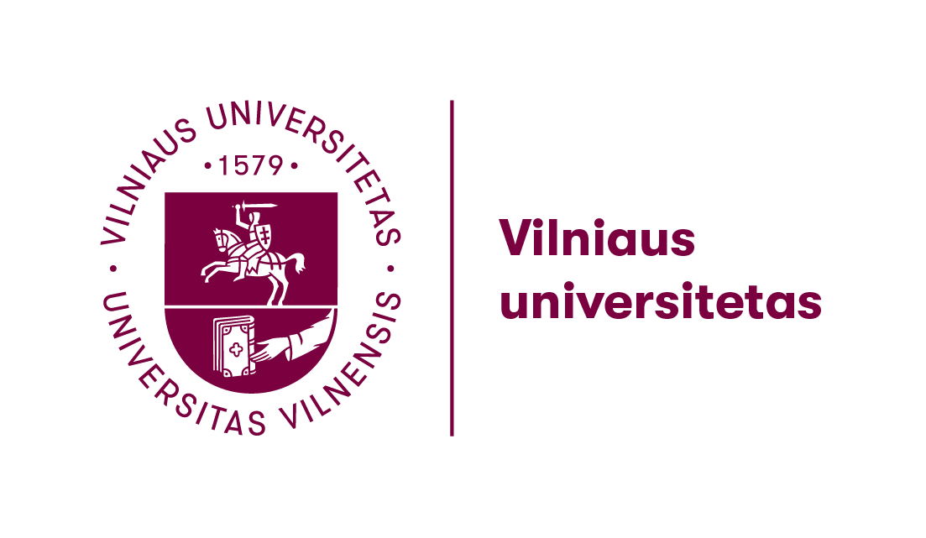
Welcome to a lecture by
dr. Torben Jelsbak (Copenhagen University)
From Bauhaus to Our House – Kritisk Revy, Popular Culture, and the Roots of “Scandinavian Design”
Friday, the 10th of May, 13 00
Centre of Scandinavian Studies, Room 314 A/B

The Danish architectural magazine Kritisk Revy (1926–1929) occupies an important position in Scandinavian avant-garde culture of the interwar period. Edited by a group of young architects and left-wing intellectuals, with the Danish designer and critic Poul Henningsen or “PH” as a driving force, the magazine served as an ideological platform for early Scandinavian modernism in architecture and design. As such the magazine may also be regarded as an early stage in the emergence and construction of the notion of “Scandinavian Design”. This lecture will explore how Kritisk Revy’s leading vision and concept of “humane art, art for society’s sake” was formulated in a critical dialogue with contemporary currents and positions in international modernism such as Le Corbusier, Russian constructivism and the German Bauhaus School.

Torben Jelsbak is an Associate Professor at the Department of Nordic Studies and Linguistics, Copenhagen University. His current research concerns the interrelationship and exchange between the 20th century modernist avant-gardes and contemporary media and popular culture. For the list of Torben’s publications and more information about his activities please visit his profile at https://nors.ku.dk/english/staff/?pure=en%2Fpersons%2Ftorben-jelsbak(385bf3e2-8189-4050-9b3a-7b63952e8fa6)%2Fpublications.html

